Client’s First Name Benefit Report

You’ll Get Ahead by Working!

Income and Health Coverage Snapshot
When you earn $ [earnings goal 1] /month:
- You will have Choose an item. income
- Your health care coverage through [program] is expected to [impact of earnings goal 1 on health coverage]
When you earn $[earnings goal 2]/month:
- You will have Choose an item. income
- Your health care coverage through [program] is expected to [impact of earnings goal 2 on health coverage]

Benefit Report for: Client’s first name Client’s last name
Created by:
Benefit Coach’s Organization
Prepared by:
Benefit Coach’s Name
Date report was created:
Enter Date

Your Current Situation & Work Plans

Your Current Benefits
I’ve checked with these agencies: [list of agencies, such as Social Security Administration (SSA), Department of Human Services (DHS), etc.].
I verified that you get:
- $[current SSDI monthly benefit]/month net Social Security Disability Insurance (SSDI)
- $[current SSI monthly benefit]/month Supplemental Security Income (SSI)
- $[current MSA monthly benefit]/month Minnesota Supplemental Aid (MSA)
- $[current GA monthly benefit]/month General Assistance (GA)
- $[current SNAP monthly benefit]/month Supplemental Nutrition Assistance Program (SNAP)
- $[current MFIP monthly benefit]/month Minnesota Family Investment Program (MFIP)
- Medical Assistance (MA) [type and premium/spenddown amount]
- Medicare (Part A, Part B and Part D)
- Medicare Part B premium payment assistance
- Medicare Part D Low Income Subsidy (Extra Help)
- [others]


Your Work Plans
You told me:
- [Description of current work & earnings level, if applicable]
- You get employment services from: [list of agencies]
- You said you may need help with: [Description of supports and services needed to reach goal]
We talked about the following possible future earnings plans:
- Plan 1: $[earnings goal 1]/month
- [Description of Goal 1]
- Plan 2: $[earnings goal 2]/month
- [Description of Goal 2]

Your Cash Benefits & Work

Choose an item.

You are in your [Current phase of SSDI work incentives].
During this phase:
- When you earn $[earnings goal 1]/month: Your SSDI is expected to [impact of earnings goal 1 on SSDI benefit]. Your total income will be [total income with earnings goal 1].
- When you earn $[earnings goal 2]/month: Your SSDI is expected to [impact of earnings goal 2 on SSDI benefit]. Your total income will be [total income with earnings goal 2].
You can learn more in DB101’s SSDI article.

Supplemental Security Income (SSI)
With SSI, you always have more income when you work, even if your SSI goes down.

- When you earn $[earnings goal 1]/month: Your SSI is expected to [impact of earnings goal 1 on SSI benefit]. Your total income will be [total income with earnings goal 1].
- When you earn $[earnings goal 2]/month: Your SSI is expected to [impact of earnings goal 2 on SSI benefit]. Your total income will be [total income with earnings goal 2].
You can learn more in DB101’s SSI article.

Minnesota Supplemental Aid (MSA)
With MSA, you always have more income when you work, even if your MSA goes down.
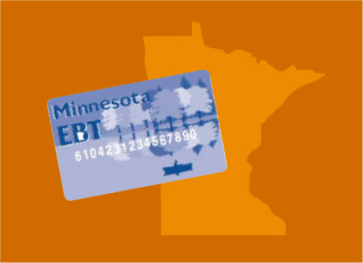
- When you earn $[earnings goal 1]/month: Your MSA is expected to [impact of earnings goal 1 on MSA benefit]. Your total income will be [total income with earnings goal 1].
- When you earn $[earnings goal 2]/month: Your MSA is expected to [impact of earnings goal 2 on MSA benefit]. Your total income will be [total income with earnings goal 2].
You can learn more in DB101’s MSA article.

General Assistance (GA)
With GA, you always have more income when you work, even if your GA goes down.
- When you earn $[earnings goal 1]/month: Your GA is expected to be $[GA with earnings goal 1]/month. Your total income will be [total income with earnings goal 1].
- When you earn $[earnings goal 2]/month: Your GA is expected to be $[GA with earnings goal 2]/month. Your total income will be [total income with earnings goal 2].
You can learn more in DB101’s GA article.

Supplemental Nutrition Assistance Program (SNAP)
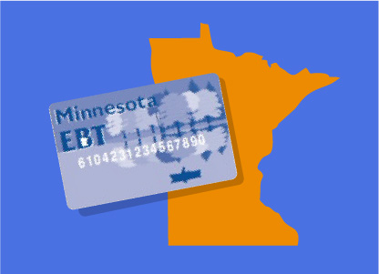
- When you earn $[earnings goal 1]/month: Your SNAP is expected to be $[SNAP with earnings goal 1]/month. Your total income will be [total income with earnings goal 1].
- When you earn $[earnings goal 2]/month: Your SNAP is expected to be $[SNAP with earnings goal 2]/month. Your total income will be [total income with earnings goal 2].
You can learn more in DB101’s SNAP article.

Minnesota Family Investment Program (MFIP)
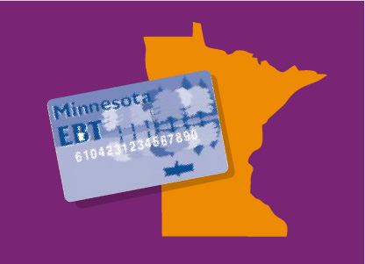
- When you earn $[earnings goal 1]/month: [Your/your children’s] MFIP is expected to [impact of earnings goal 1 on MFIP benefit]. Your total income will be [total income with earnings goal 1].
- When you earn $[earnings goal 2]/month: [Your/your children’s] MFIP is expected to [impact of earnings goal 2 on MFIP benefit]. Your total income will be [total income with earnings goal 2].
You can learn more in DB101’s MFIP article.

Section 8 Housing Choice Voucher

- When you earn $[earnings goal 1]/month: Your rent is expected to be $[rent with earnings goal 1]/month. [Earned income disregard statement, if it applies]
- When you earn $[earnings goal 2]/month: Your rent is expected to be $[rent with earnings goal 2]/month. [Earned income disregard statement, if it applies]
You can learn more in DB101’s Housing article.

Housing Support (formerly GRH)
With Housing Support, you always have more income when you work, even if your Housing Support goes down.
- When you earn $[earnings goal 1] /month: The amount you pay your Housing Support provider is expected to be [Housing Support with earnings goal 1].
- When you earn $[earnings goal 2]/month: The amount you pay your Housing support provider is expected to be [Housing Support with earnings goal 2].
You can learn more in DB101’s Housing article.

Your Health Coverage

Medical Assistance (MA)
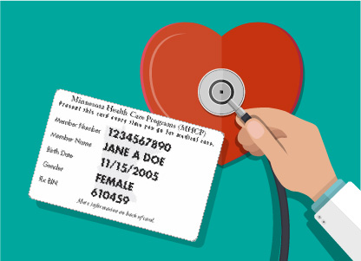
- When you earn $[earnings goal 1]/month: Your MA is expected to [impact of earnings goal 1 on MA benefit].
- When you earn $[earnings goal 2]/month: Your MA is expected to [impact of earnings goal 2 on MA benefit].
You can learn more in DB101’s MA Overview article.

Medical Assistance for Employed Persons with Disabilities (MA-EPD)
- When you earn $[earnings goal 1]/month: Your MA-EPD is expected to [impact of earnings goal 1 on MA benefit].
- When you earn $[earnings goal 2]/month: Your MA-EPD is expected to [impact of earnings goal 2 on MA benefit].
You can learn more in DB101’s MA Overview article.

MA-Waiver Programs
- When you earn $[earnings goal 1]/month: Your [waiver name] is expected to [impact of earnings goal 1 on MA-Waiver program].
- When you earn $[earnings goal 2]/month: Your [waiver name] is expected to [impact of earnings goal 2 on MA-Waiver program].
You can learn more in DB101’s MA-Waivers Programs article.

Medicare
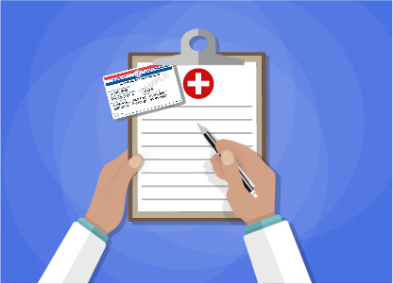
- When you earn $[earnings goal 1] /month: Your Medicare is expected to [impact of earnings goal 1 on Medicare].
- When you earn $[earnings goal 2]/month: Your Medicare is expected to [impact of earnings goal 2 on Medicare].
You can learn more in DB101’s Medicare article.

Medicare Part B: Help with Costs
Right now, the state pays your Medicare Part B premium because [reason – QMB/SLMB/MA-EPD, etc.].
- When you earn $[earnings goal 1]/month: Your [name of Part B assistance] is expected to [impact of earnings goal 1 on Part B assistance].
- When you earn $[earnings goal 2]/month: Your [name of Part B assistance] is expected to [impact of earnings goal 2 on Part B assistance].
You can learn more in DB101’s Medicare article.

Medicare Part D Low Income Subsidy
- When you earn $[earnings goal 1]/month: Your Part D Low Income Subsidy is expected to [impact of earnings goal 1 on Low Income Subsidy].
- When you earn $[earnings goal 2]/month: Your Part D Low Income Subsidy is expected to [impact of earnings goal 2 on Low Income Subsidy].
You can learn more in DB101’s Medicare article.

Managing Your Benefits & Reporting Your Income
[Copy and paste results of My Vault’s “Managing Benefits” activity here]
If you have any questions, talk to Disability Hub MN at 1-866-333-2466.

Next Steps
- Carefully review this summary and ask for clarification if you have any questions
- Person responsible: [Client’s first name] and [Benefit Coach’s first name]
- Target date:
- Completion date:
- Contact your Benefit Coach when you have a job offer, so they can update this report.
- Person responsible: [Client’s first name]
- Target date: When job is offered
- Completion date:
- [Enter a third action step here if applicable]
- Person responsible:
- Target date:
- Completion date:

Important Things to Remember
[Include important things to remember here]

Agencies That Can Help
Disability Hub MN
Contact: [Contact name and title, if applicable. If not, delete this line]
Phone: 1-866-333-2466
Web: www.disabilityhubmn.org
[Agency name]
Contact: [Contact name and title, if applicable. If not, delete this line]
Address:
Phone:
Web:

Using This Report
- Keep this report and come back to it when you have questions about how your employment plans may affect your income and benefits.
- Share this report with other people who are helping you with benefits and work.

If Your Situation Changes
Changes in your situation may seriously affect the accuracy of this report. Contact me right away to discuss any changes in your benefits or employment plans, or if you have any more questions about how work may affect your benefits.

My Contact Information
Benefit Coach’s Name
Benefit Coach’s Phone Number
Benefit Coach’s Email

